**Assignment-1: Hadoop Commands**

**Chaitanya Sai Nutakki  
AP21110010253**

1. Creating a directory in HDFS at the given path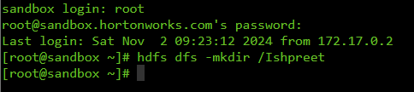
2. List the contents of a directory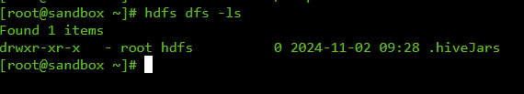
3. Upload and download a file in HDFS
   1. Using put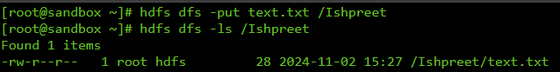
   2. Using get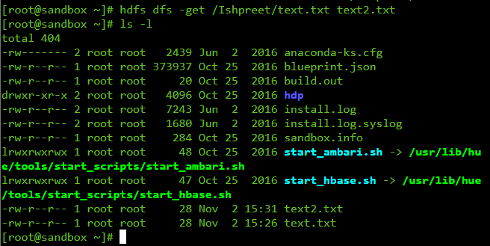
4. See the contents of a file
5. Copy the file from source to destination 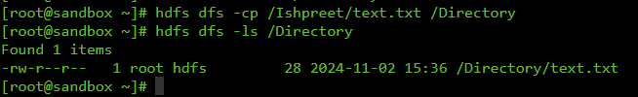
6. Copy a file from / (local file system) to HDFS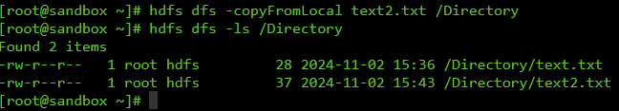
7. Move the file from source to destination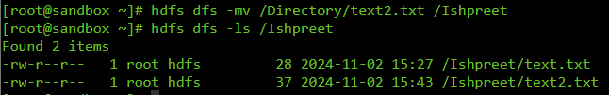
8. Remove a file/directory in HDFS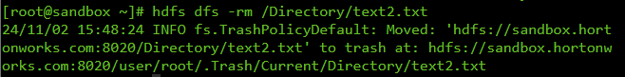
9. Display the last few lines of a file
10. Display the aggregate length of a file